

Friends Society, Vadodara
SEXUAL HARASSMENT
PREVENTION, PROHIBITION AND REDRESS
POLICY & PROGRAM
December 2018 (v.2)

- Introduction 2
- Policy 2
- FS Internal Complaints Committee (FS ICC) 2
- FS ICC Procedures 3
Content for Educational and Awareness Program
Appendix A: What is Sexual Harassment 5
Appendix B: Examples of What is Sexual Harassment 7
Appendix C: Process for Filing a Complaint with FS ICC 9
Appendix D: Definitions 12



A. INTRODUCTION
This document outlines policy and program (procedures) related to prevention, prohibition and redress of sexual harassment of female (as well as male) volunteers, staff and beneficiaries while they are engaged in any activity sponspored by Friends Society.
The information in this document is based on the requirements of the “Sexual Harassment of Women at Workplace Act of 2013” as outlined in the Handbook published by the Government of India, Ministry of Women and Child Development (November 2015). As clarified in the handbook, the requirements outlined here also meet the requirements of the Vishaka Guidelines (1997) issued by the Supreme Court of India and which are legally binding, and the United Nation’s (UN’s) 1979 Convention on the Elimination of all forms of Discrimination Against Women (CEDAW) – also called “International Bill of Rights for Women” – that was ratified by India in 1993.
B. POLICY
- Friends Society (FS) will ensure work environment that is free from sexual harassment for all its volunteers, staff and beneficiaries. This applies to activities at the FS operations at the Petit Library or carried out anywhere else.
- FS will create an Internal Complaints Committee as described in the next section. Its members will be appointed by the Board of Trustees.
- When a complaint is filed and investigated by the FS Internal Complaints Committee (ICC), the complaint is upheld by the Committee, and the ICC report is submitted, the Board of Trustee will take actions it deems necessary for the given situation, including expelling a member or staff who may have been involved.
C. FS INTERNAL COMPLAINTS COMMITTEE
- The FS Board of Trustees will form an Internal Complaints Committee (FS ICC) and will appoint its members as follows.
- The FS ICC will have at least four members:
  - Chairperson of FS ICC will be a senior member of FS and would be a woman
  - One FS student volunteer member who could be male or female
  - One FS paid staff member, preferably a woman
  - An external person from another organization in Vadodara who has expertise on sexual harassment related matters. This member should have five years of experience as a social worker involved in women’s empowerment issues or should be a professional who has five years of involvement in handling sexual harassment matters in any organization
  - At least 50% of the FS ICC members will be women.
  - Additional members as decided by the FS Trustees
- The committee members will be appointed for a three-year term. When a vacancy on the committee arises, the Board of Trustees will appoint another person to fill the vacancy.
KEY RESPONSIBILITIES
      - Be thoroughly prepared
      - Know the Act, Policy and/or relevant Service Rules
      - Gather and record all relevant information
      - Determine the main issues in the complaint
      - Prepare relevant interview questions
      - Conduct necessary interviews
      - Ensure parties are made aware of the process and their rights/responsibilities within it
      - Analyse information gathered
      - Prepare the incident report with findings/recommendations; submit to the Board of Trustees
      - Prepare an annual report for the Board of Trustees
KNOWLEDGE, SKILLS, TRAINING
Dealing with workplace sexual harassment complaints is often complex. Hence Complaints Committee must possess critical skills/capacity to effectively carry out its role. That includes a sound grasp of the Act, Vishaka Guidelines, applicable Service Rules, relevant laws and an understanding of workplace sexual harassment and related issues. Their skills must include an ability to synthesise information from relevant documents and interviews.
They should also be able to communicate effectively, write clearly, listen actively and conduct interviews. They should be competent at showing empathy, being impartial and being thorough. They should be able to identify sexual harassment and its impact.
D. FS ICC PROCEDURES
- The FS ICC members will receive annual training on what constitutes sexual harassment, process for filing a complaint, and how to handle / investigate complaints and related time frames. This training should occur during July or August each year.
- All the Committee proceedings, deliberations, files and other documentation generated during their work will be kept confidential; access will be provided only to the current chairperson of FS ICC and a FS trustee designated by the Board of Directors.
- The Committee shall meet as a group as needed, but at least once a year.
- The existence of the FS ICC and names of its members, with their contact information, should be widely publicized at FS.
- The FS ICC will also have a responsibility to work with the Board of Trustees and the Executive Committee (EC) to ensure that proper communication for prevention occurs through awareness and education of all involved in FS activities and operations. Suggested content of such education and awareness programs are suggested in Appendix A: “What is Sexual Harassment?”, Appendix B: “Examples of what is sexual harassment,” and Appendix D: “Definitions.”
- Sexual harassment complaint process should also be explained to all in clear and simple terms (See Appendix C, “Process of filing a complaint with FS ICC”).
- The FS ICC will prepare an annual report and submit it to the Board of Trustees by June 30th every year. The report must include the following information:
  - No. of complaints received during the year
  - No. of complaints disposed of (brought to conclusion)
  - No. of cases which had remained open for more than 90 days from the date the complaints were received
  - Nature of actions recommended for the complaints that were upheld
  - Summary of awareness and education activities conducted during the year

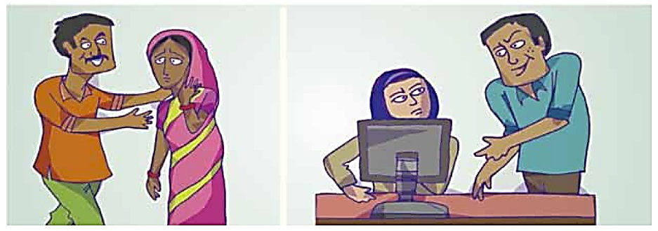

CONTENT FOR EDUCATIONAL & AWARENESS PROGRAM
The following Appendices provide information that should be used for awareness and education of FS volunteers and staff. Any other pertinent information could also be used in developing training materials.
APPENDIX A: WHAT IS SEXUAL HARASSMENT

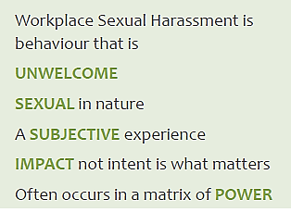
Sexual harassment includes unwelcome sexual advances, requests for sexual favors, and other verbal or physical harassment of a sexual nature in the workplace or learning environment. Sexual harassment is a broad term, including many types of unwelcome verbal and physical sexual attention.

Five elements of sexual harassment:

“Sexual Harassment” includes any one or more of the following unwelcome acts or behaviour
(whether directly or by implication), namely:
1. Physical contact or advances
2. A demand or request for sexual favours
3. Making sexually coloured remarks
4. Showing pornography
5. Any other unwelcome physical, verbal or non-verbal conduct of a sexual nature
Key points about sexual harassment:
- It is important to remember that workplace sexual harassment is sexual, unwelcome and the experience is subjective
- It is the impact that matters, not the intent
- Very often situations that start off innocently end up in inappropriate and unprofessional behaviours
- It almost always occurs in a matrix of power
- It is possible that a woman may experience a single instance of sexual harassment or a series of incidents over a period
- Each case is unique and should be examined in its own context and according to the surrounding circumstances as a whole

Forms of workplace sexual harassment
Generally, workplace sexual harassment refers to two common forms of inappropriate behaviour:
Quid Pro Quo (literally ‘this for that’)
      - Implied or explicit promise of preferential/detrimental treatment in employment
      - Implied or express threat about her present or future employment status
Hostile Work Environment
      - Creating a hostile, intimidating or an offensive work environment
      - Humiliating treatment likely to affect her health or safety
Welcome and unwelcome behaviours:
It is critical to recognize and differentiate between welcome and unwelcome sexual behaviour.
Listed are some examples of how “unwelcome” and “welcome” behaviour is experienced.
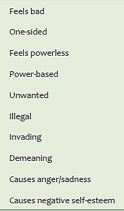
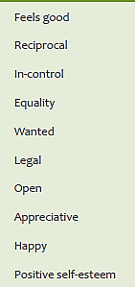
UNWELCOME behavior experienced as -
WELCOME behavior experienced as -

There are differences between assault, harassment and misconduct.
Sexual assault refers to sexual contact or behavior, often physical, that occurs without the consent of the victim. It refers to acts that are criminal.
Sexual harassment generally violates civil laws - you have a right to work or learn without being harassed - but in many cases is not a criminal act.
Sexual misconduct is a non-legal term used informally to describe a broad range of behaviors, which may or may not involve harassment.

SEXUAL HARASSMENT IS A SUBJECTIVE EXPERIENCE
In 2010, the High Court of Delhi endorsed the view that sexual harassment is a subjective experience and for that reason held “We therefore prefer to analyze harassment from the [complainant’s] perspective. A complete understanding of the [complainant’s] view requires ... an analysis of the different perspectives of men and women.
Conduct that many men consider unobjectionable may offend many women... Men tend to view some forms of sexual harassment as “harmless social interactions to which only overly-sensitive women would object. The characteristically male view depicts sexual harassment as comparatively harmless amusement.
... Men, who are rarely victims of sexual assault, may view sexual conduct in a vacuum without a full appreciation of the social setting or the underlying threat of violence that a woman may perceive.”
Dr. Punita K. Sodhi v. Union of India & Ors. W.P. (C) 367/2009 & CMS 828, 11426/2009
On 9 September, 2010, in the High Court of Delhi

APPENDIX B: EXAMPLES OF WHAT IS SEXUAL HARASSMENT

- Making sexually suggestive remarks or innuendos.
- Serious or repeated offensive remarks, such as teasing related to a person’s body or appearance.
- Offensive comments or jokes.
- Inappropriate questions, suggestions or remarks about a person’s sex life.
- Displaying sexist or other offensive pictures, posters, MMS, SMS, WhatsApp, or e-mails.
- Intimidation, threats, blackmail around sexual favours.
- Threats, intimidation or retaliation against an employee who speaks up about unwelcome behaviour with sexual overtones.
- Unwelcome social invitations, with sexual overtones commonly understood as flirting.
- Unwelcome sexual advances which may or may not be accompanied by promises or threats, explicit or implicit.
- Physical contact such as touching or pinching.
- Caressing, kissing or fondling someone against her will (could be considered assault).
- Invasion of personal space (getting too close for no reason, brushing against or cornering someone).
- Persistently asking someone out, despite being turned down.
- Stalking an individual.
- Abuse of authority or power to threaten a person’s job or undermine her performance against sexual favours.
- Falsely accusing and undermining a person behind closed doors for sexual favours.
- Controlling a person’s reputation by rumour-mongering about her private life.


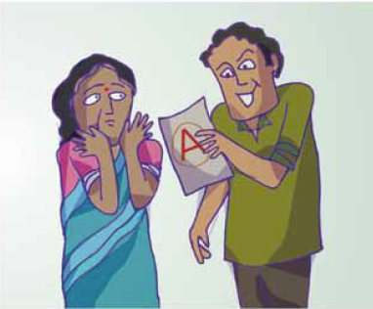
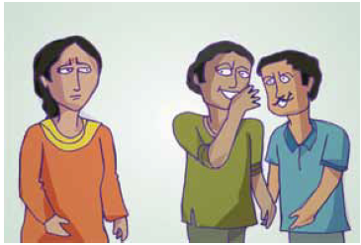

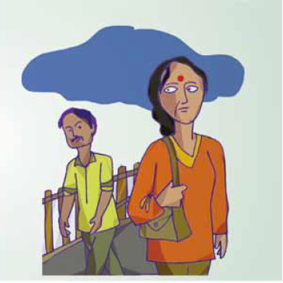


“The meaning and content of fundamental rights in the Constitution of India are of sufficient amplitudes to encompass all facets of gender equality” – Late Justice J. S. Verma

Sexual harassment results in violation of the fundamental rights of a woman to equality (Articles 14 and 15 of the Constitution of India) and her right to live with dignity (Article 21).

APPENDIX C: PROCESS FOR FILING A COMPLAINT WITH FS ICC

What should the complaint contain?
The written complaint should contain a description of each incident(s). It should include relevant dates, timings and locations; name of the respondent(s); and the working relationship between the parties. A person designated to manage the workplace sexual harassment complaint is required to provide assistance in writing of the complaint if the complainant seeks it for any reason.
What can an employee/worker expect?
When it comes to redress for workplace sexual harassment, employee/worker has a right to expect -a trained, skilled and competent Complaints Committee, a time bound process, information confidentiality, assurance of non-retaliation, counselling or other enabling support where needed and assistance if the complainant opts for criminal proceedings.
Rights of the complainant
      - An empathetic attitude from the Complaints Committee so that she can state her grievance in a fearless environment
      - A copy of the statement along with all the evidence and a list of witnesses submitted by the respondent
      - Keeping her identity confidential throughout the process
      - Support, in filing criminal complaint in case she chooses to lodge criminal proceedings
      - In case of fear of intimidation from the respondent, her statement can be recorded in absence of the respondent
      - Right to appeal, in case, not satisfied with the recommendations/findings of the Complaints Committee
Rights of the respondent
      - A patient hearing to present his case in a non-biased manner
      - A copy of the statement along with all the evidence and a list of witnesses submitted by the complainant
      - Keeping his identity confidential throughout the process
      - Right to appeal in case not satisfied with the recommendations/findings of the Complaints Committee

Any woman who wishes to report instances of sexual harassment at the workplace has the right to take recourse of both civil and criminal proceedings.

The Complaints Committee needs to have information on the six stages (including fifteen steps), detailed below, for addressing a complaint of workplace sexual harassment.
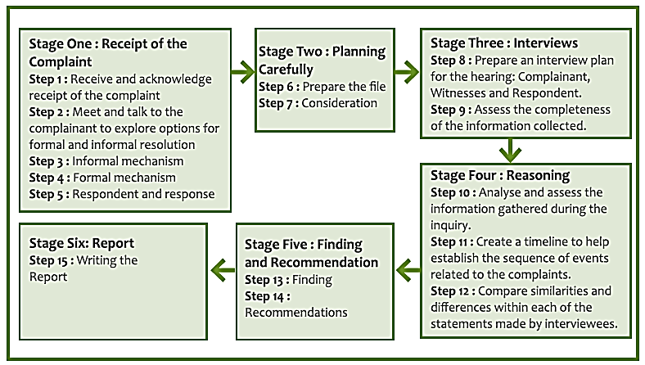

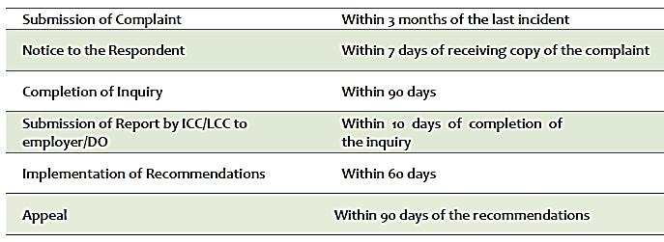

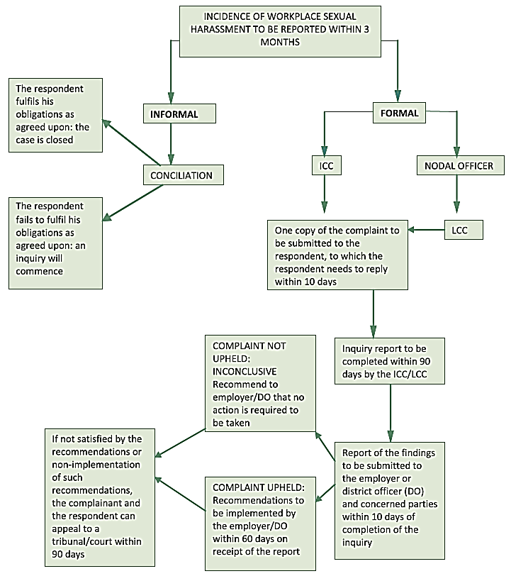

APPENDIX D: DEFINITIONS
Workplace
A workplace is defined as “any place visited by the employee arising out of or during the course of employment, including transportation provided by the employer for undertaking such a journey.”
For Friends Society, the workplace includes the FS Campus and all external locations where FS activities are being conducted.
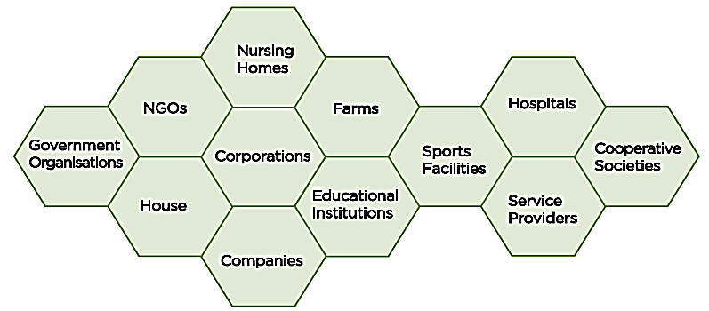

Redress
Act of setting right an unjust situation, remedy
Aggrieved woman
Someone who is distressed or has been harmed or treated poorly; it could be a volunteer, a trustee, an EC member, a staff member, or a beneficiary of Friends Society.
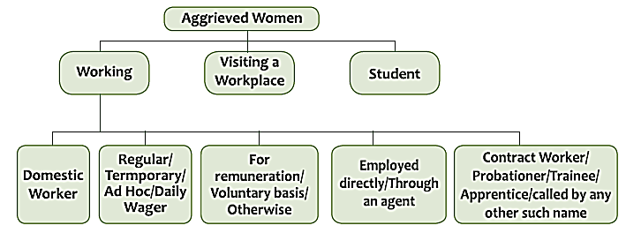

Matrix of power
This term is used in the Handbook (which is referred to in the Introduction). It is one of the five components which constitute sexual harassment. It simply means those having authority and power over others.
Quid Pro Quo
Sexual harassment in which the satisfaction of sexual demands is made the condition of job benefits or continued employment or is used as the basis for employment decisions regarding the individual.

- END - fs - sexual harassment policy and procedure - dec 2018 - v2

